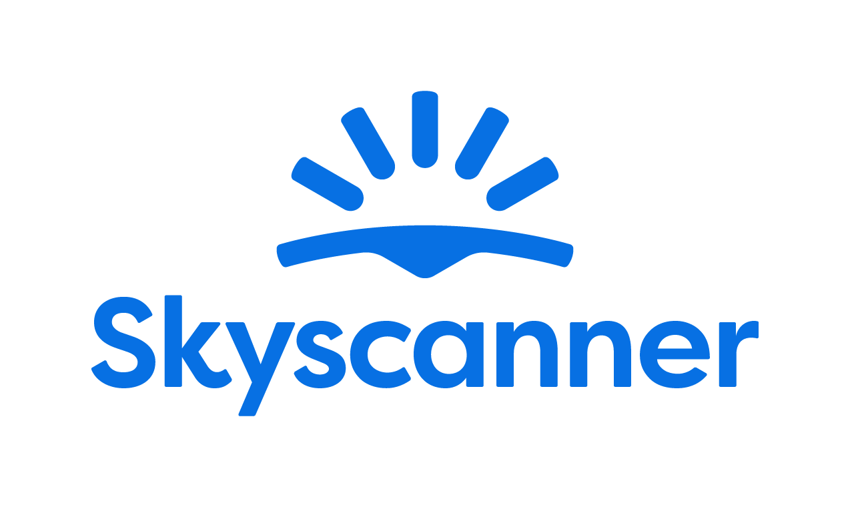

Localisation Style Guide

How to write and translate for Skyscanner in Finnish

1. Our Tone of Voice 4
1.1 Playful 4
1.2 Geeky 5
1.3 Helpful 6
1.4 Using the tone of voice in localisation 7
2. General writing and translation guidelines 9
2.1 URL requirements 9
2.2 Placeholders, variables and tags 9
2.3 Inclusive language 10
3. Language-specific translation guidelines
11
3.1. Punctuation and spacing 11
3.1.1. Use of non-breaking space 11
3.2. Emphasis and intensifiers 11
3.3. References 11
3.4. Capitalisation 12
3.4.1. Titles and CTAs 12
3.4.2. Glossary terms / product names 12
3.5. The use of Anglicisms 12
3.6. Abbreviations and acronyms 13
3.7. CTAs and active voice 13
3.8. Linguistic sequence 13
3.8.1. Transliteration 13
3.8.2. Geo-terms 13
3.8.3. Airport names 14
4. Cultural sensitivity 14
4.1. Emojis and symbols 14
4.2. Imagery 15
5. Translation guidelines per content type 15
5.1. User Interface (UI) 15
5.2. Marketing 15
5.3. SEO 16
5.4. Google Ads 16
5.5. App store 16
5.6. Editorial and blog posts 17
5.7. Emails and push notifications 17
5.8. Legal, Policies, Terms and conditions 17
6. Other Skyscanner-specific guidelines 18
6.1. Use of Skyscanner brand 18
6.2. Feature naming 18
6.3. The use of “Best” 19
6.4. The use of “Discount” 20
6.5. Translating sustainability-related content 20
6.6. Accessibility guidelines 21
7. Useful resources and links 21

Our Tone of Voice

Skyscanner sounds like a Geeky Travel Pal. This means that:
- Our tone is playful
- Our energy is geeky
- Our message is helpful
Our brand promise is to be a helpful, honest travel ally. Our tone of voice should always support this:
- We give clear, useful information so travellers feel savvy.
- We are fair and transparent, so travellers feel confident and secure.
- We lead with empathy, so travellers feel valued and understood.
When localising, keep the same personality, but adapt expressions so they feel natural in your language and culture.

1.1 Playful
Our tone is playful. We write with a light, natural energy. Playfulness helps us feel human and builds trust – but it must never reduce clarity.
What playful means for us:
- A conversational tone, as if talking to a friend.
- A rhythm that feels lively, not flat or robotic.
- Turning travel frustrations into simple tips and “travel hacks”.
Example:
Instead of: Kun voit vertailla useita lentoyhtiöitä samaan aikaan, et tarvitse useita välilehtiä.
We’d say:
Do | Don’t
Viimeinkin voit vertailla lentoja ilman sellaista välilehtimäärää, että tietokoneellekin tulee hiki. | Varoitus: hintavertailutyökalumme löytää tarjouksia nopeammin kuin rakettirepun voimalla kiitävä supersankari! Turvavyöt kiinni, nyt haetaan säästöjä.

Use these tools when they feel natural and keep meaning clear (and when they work in your language):
- Rhyme – e.g. “Halvat hinnat, upeat lomat.”
- Alliteration – e.g. “Leppoisasti lomatunnelmiin.”
- Metaphors – e.g. “Halvat hinnat voivat olla kuin pilviä: ne lipuvat tiehensä ennen kuin huomaatkaan.”
- More vivid adjectives – e.g. “säkenöivä” instead of “kirkas”
Use these tools sparingly and only if they localise well:
- Puns (Nothing too obvious or too corny).
- Elongated vowels – e.g. “Mahtavaaaaaa”.
- Interjections – e.g. “Oho. Pyh. Heh.”
Always choose clarity over wordplay. If a device is hard to adapt or sounds unnatural in your language, do not use it.
Avoid
- “Fake-smart” corporate or management speak.
- Overly formal or stiff phrases.
- Trying too hard to be “LOL-funny”.

1.2 Geeky
Our energy is geeky: we love data, details and patterns – and we explain them in a human way.
What geeky means for us:
- We sound excited to share what we’ve learned.
- We show our travel expertise and curiosity.
- We break down complex information into simple steps.
Keep the tone enthusiastic but controlled. It should feel like a knowledgeable friend, not a lecture.
Instead of: Me tunnemme isoimpien lentoyhtiöiden matkatavararajoitukset, jotta voit välttyä maksuilta ja stressiltä.
We’d say:
Do | Don’t
Tunnemme 137 lentoyhtiön matkatavaroiden painorajoitukset, joten et joudu murehtimaan maksuja. | Haluatko kovaa faktaa matkatavaroiden painorajoituksista? Meillä on tiedot GRAMMAN TARKKUUDELLA 137 lentoyhtiöltä!!!

1.3 Helpful

Helpful is our foundation. If you must choose between playful, geeky and helpful, be helpful first.
Our writing should:
- Make complex travel information simple.
- Make confusing situations clear.
- Make overwhelming choices manageable.
Instead of: Skyscannerilla on reaaliaikaiset tiedot halvimmista lennoista eri viikonpäivinä.
We’d say:
Do | Don’t
Kiinnostaako halvin matkustuspäivä? Meiltä se löytyy. | Jos haluat selvittää halvimman matkustuspäivän, mutta sivustojen ja välilehtien määrä ahdistaa, hengitä syvään! Sitä varten me olemme täällä.

How to write helpfully
1. Put travellers first
- Focus on what they need to know, not on us.
- Start with the benefit or instruction, then explain how we know.
- Ask nicely - to help the traveller take action, they’ll be more inclined if we’re polite and respect their time.
Do | Don’t
Löydät parhaat lentojen hinnat tuhansien vaihtoehtojen joukosta | Haemme tuhansia lentovaihtoehtoja, jotta saat parhaat hinnat
Matkanjärjestäjä on vahvistanut varauksesi | Matkanjärjestäjä on käsitellyt maksun ja varaus on vahvistettu
Luethan ohjeet | Lue ohje

2. Be honest, upfront and take responsibility
When sharing bad news or apologising:
- Drop most of the playfulness.
- Always apologise if something is our fault. If it isn’t, show empathy instead.
- Be clear about what happened, what will happen next, and what we’re doing to fix it.
- Say sorry once, sincerely. Focus on solutions, not on how bad we feel.
- Avoid cold phrases like “We apologise for the inconvenience.
Do | Don’t
Valitettavasti lentoyhtiö on perunut lentosi. Ymmärrämme, miten turhauttavaa tämä on, mutta ei huolta. Teemme kaikkemme, jotta saat hyvityksen. | Lentoyhtiö on perunut lentosi. Katsotaan, saataisiinko sinulle lentoyhtiöltä hyvitys.
Valitettavasti lentoyhtiö on perunut varauksesi. | Sori, lentoyhtiö on perunut varauksesi.
Valitettavasti jokin meni pieleen emmekä pysty näyttämään lentovaihtoehtoja. Kokeile hakea uudestaan heti tai palaa asiaan vähän myöhemmin. | Valitettavasti jokin meni pieleen emmekä pysty näyttämään lentovaihtoehtoja. Pahoittelut mahdollisesta haitasta.

3. Keep it short and simple
- Use short sentences and simple structures.
- Remove unnecessary words and repetition.
- Where you can, opt for the “pose question then offer solution” format.
Do | Don’t
Tarvitsetko apua? Ota yhteyttä asiakaspalvelutiimiin. | Ota yhteyttä asiakaspalvelutiimiimme, jos olet avun ja neuvojen tarpeessa.

1.4 Using the tone of voice in localisation
When translating or adapting content for Skyscanner:
- Keep the three qualities – playful, geeky, helpful – but express them in ways that fit your language and culture.
- Prioritise meaning and clarity over matching English phrasing.
- Replace wordplay (rhyme, alliteration, puns) with devices that work naturally in your language – or skip them if needed.
- Keep the friendly, human, travel-loving personality in every sentence.
Your goal: in every market, travellers should read the text and think,
“This sounds like a smart, friendly travel pal who’s genuinely here to help.”

General writing and translation guidelines

URL requirements
When translating or creating URLs for Skyscanner, follow these technical rules to keep URLs consistent, readable and safe across all markets. These are very important, since not following the guidelines may result in whole pages breaking and being unavailable for the audience.

- No spaces - If you need to separate words, use a standard hyphen -.
Do | Don’t
syksyn-tarjoukset | syksyn tarjoukset

- All lowercase

Do | Don’t
kaupunkilomat | Kaupunkilomat

- No extended or special characters. Replace them with the basic Latin letter.
Do | Don’t
o, a, e, n, c | ö, ä, è, ñ, ç

Placeholders, variables and tags
Placeholders, variables and tags are there to make the text dynamic (e.g. inserting a city, date or price) or to format it. They must not be translated, deleted or changed.

Always keep them exactly as in the source, placed in the correct order, and make sure the sentence is still natural and grammatically correct in your language. Make sure to insert spaces where needed before/after the tags to avoid words being glued together when the placeholders are populated.

In case the placeholder is not supported by the translation tool and shows as editable text instead of a tag, make sure not to translate the content but keep it as in English.

In Finnish, a workaround is needed to ensure the sentence with a placeholder is grammatically correct. One way to do this is to add a noun (such as “kohde”) before the placeholder to allow inflection:
English: “Search flights to @@city@@
Workaround: “Hae lentoja kohteeseen @@city@@”

This workaround is not optimal since it makes the text read like a translation, but it cannot always be avoided. Other, less visible workarounds should be used whenever possible (for example using en dash structure):

English: “Cheap flights to @@city@@
Workaround: “Halvat lennot – @@city@@”

Inclusive language
Our language should be inclusive, welcoming and respectful to all travellers. When translating for Skyscanner, avoid stereotypes, unnecessary references to gender, family, age, ability, or background, and choose wording that includes as many people as possible. Always prefer neutral, precise terms over clichés or labels.
- Use gender-neutral language where possible.
- Do not assume who people travel with, how they look, or what they can do.
- Avoid jokes or idioms that rely on stereotypes about nationality, age, gender, religion, or any other group.
- Focus on travellers’ needs and situations, not on labels.

Do | Don’t
Täydellinen vaihtoehto ryhmille, pariskunnille ja yksin matkustaville. | Täydellinen vaihtoehto koko perheelle äitiä, isää ja lapsia myöten
Ihanteellinen matkustajille, jotka haluavat rentoutua hiljaisuudessa. | Ihanteellinen vanhuksille, jotka eivät pidä melusta.
Jotkin kadut ovat jyrkkiä ja voivat olla hankalia liikuntarajoitteisille. | Tämä alue ei sovi liikuntavammaisille.
Paikallisista ravintoloista löytyy hyvin vaihtoehtoja eri ruokavalioiden ja mieltymysten mukaan. | Paikallisista ravintoloista vaihtoehtoja niin normaalille kuin erikoisruokavalioillekin.

Language-specific translation guidelines

Punctuation and spacing
Refer to Kielitoimiston ohjepankki (https://kielitoimistonohjepankki.fi) for information about grammar and punctuation.

Use of non-breaking space
Non-breaking spaces prevent closely related parts of the text from being separated into different lines. These should be used between numbers and percentage signs or currency symbols and in other similar cases, such as:
20 %
8 km
45 €
10 000

Emphasis and intensifiers
Sometimes we use formatting and wording to emphasise key information for it to be easy to spot, or as an intensifier for a part of the message.
In Finnish, sentence structure and italics are typical ways to display emphasis.
As a rule of thumb, prefer simple formatting (bold or italics) for emphasis and avoid using ALL CAPS or too many exclamation marks, as they can feel like shouting or spammy marketing.
Do | Don’t
Löydä juuri sellainen auto kuin haluat 🚘 | Löydä SELLAINEN AUTO KUIN HALUAT 🚘
 | Löydä sellainen auto kuin haluat!!!!! 🚘🚘

References
When you refer to other content (pages, features, sections, links), use clear, consistent names and, where relevant, the exact label used in the UI. Quotation marks can be used for clarity especially when the reference has multiple words.
Do | Don’t
Napsauta “Takaisin hakutuloksiin” -painiketta alla, niin pääset takaisin Skyscannerin hakuun ja voit yrittää uudelleen. | Napsauta TAKAISIN HAKUTULOKSIIN -painiketta alla, niin pääset takaisin Skyscannerin hakuun ja voit yrittää uudelleen.

Capitalisation

Titles and CTAs
Use sentence case for titles and CTAs.
As a rule of thumb, we avoid title case and prefer sentence case, unless the language’s standard rules say otherwise, except for some Marketing and Ads content.
Use a capital letter for the first word and for any proper nouns and keep the rest in lower case.
Do | Don’t
Varaa nyt | Varaa Nyt
Suunnittele seuraava matkasi Skyscannerilla | Suunnittele Seuraava Matkasi Skyscannerilla

Glossary terms / product names
Glossary terms and product feature names should follow a consistent capitalisation pattern across the product. Use sentence case for descriptive unless they are treated as branded names in your language.
Keep capitalisation the same in UI and running copy, and do not switch between different styles (for example, avoid mixing “Price Alerts” and “price alerts” without a clear rule).
Examples:
Lue lisää Drops-ominaisuudesta
Löydä edullisia matkakohteita Tutustu kaikkiin kohteisiin -haulla.
Aseta hintahälytys tälle lennolle.

The use of Anglicisms
Avoid unnecessary Anglicisms if there is a clear, natural equivalent in the target language. Only keep English words when they are widely used and expected by travellers (for example, brand names or common digital terms). Make sure any English term you keep fits the tone and formality of your market and stays consistent across the product.
Do | Don’t
Use the local equivalent of “deal”, “trip”, “offer” if it sounds natural and common. | Mix English and local words in the same phrase when it feels trendy but unclear, e.g. “lentodealsit” if this is not normal usage in your market.

Abbreviations and acronyms
Use abbreviations and acronyms only when they are widely understood by travellers in your market (for example: airport codes, well-known transport terms). If there is a risk of confusion, write the full term on first mention and add the abbreviation in brackets. Avoid creating new abbreviations just to save space.

Do | Don’t
ALV sisältyy hintaan | Arvonlisävero sisältyy hintaan

CTAs and active voice
Use the active voice wherever possible, especially in headlines and CTAs. The active voice is usually clearer, and it sounds more like a direct conversation with our users.

- CTAs should be short, direct and written in the active voice.
- CTAs should be in imperative format.
- Focus on what the user can do next, using clear verbs and simple structures.
- Avoid long or vague phrases and avoid passive constructions where the user is not the clear subject.
- When adapting to each language, keep CTAs natural and action-oriented, in line with local expectations for apps and websites.

Do | Don’t
Varaa nyt | Oletko valmis varaamaan?
Tutustu karttaamme | Karttaamme tutustuminen
Näytä lentotarjoukset | Katso saatavilla oleva lentotarjousvalikoima

Linguistic sequence

Transliteration
Follow common local usage and official standards when transliterating place names, stations, and key travel terms. Be consistent within the language: don’t mix different transliteration systems in the same text. Do not invent new spellings or “localise” brand names that are normally kept in Latin script. If there is an established local exonym (well-known local version of a place name), use that; otherwise use the standard transliteration.

Geo-terms
Use the official or most widely used local names for countries, cities, regions and airports, and keep them consistent across all content. Avoid outdated, politically sensitive or rarely used forms, and don’t over-translate when travellers expect the original name (for example in airport names or well-known landmarks).
Here are some resources than can be helpful:
- https://kielitoimistonohjepankki.fi
- https://kaino.kotus.fi/eksonyymit/

Airport names
When translating airport names, refer to the official sources to make sure the name is correct.
Never add the word “airport” when translating an airport name to avoid duplication; it’s usually used to populate placeholders in a running copy, and the term “airport” is added to the copy when needed.
Example:
Lennä lentoasemalta @@airport-name@@
Do | Don’t
Charles de Gaulle | Charles de Gaullen lentoasema

Cultural sensitivity

Emojis and symbols
- Use emojis and symbols sparingly and only where they support clarity or add a light, on-brand touch.
- Make sure they are universally understood and appropriate in your market.
- Avoid replacing key words with emojis, and never use emojis in legal, policy or serious problem/incident messages.

When possible, replace any emojis or symbols present in the source copy if they are culturally inappropriate or the meaning is unclear in your market. When not possible/editable, flag the inappropriate content to Skyscanner and suggest a more suitable equivalent.

Imagery
Flag any imagery or references you encounter on Skyscanner product and other materials that could be seen as culturally inappropriate in your market (clothing, appearances, gestures, landmarks, food, family roles…)

Translation guidelines per content type

User Interface (UI)

- Be short, concise, clear and action-focused. Prioritise clarity over playfulness.
- One idea per string; avoid ambiguity and extra words.
- Use the same wording consistently across product (e.g. always “Price Alerts”, not sometimes “Price Watch”).
Do | Don’t
Näytä lennot | Katsotaanpa sitten joitain upeita lentotarjouksia, jotka on valikoitu ihan sinua varten!
Matka tallennettu | Olemme onnistuneesti suorittaneet matkasi tallennuksen
Jokin meni pieleen. Yritä uudelleen. | Hupsista, jokin meni pieleen jostakin mystisestä syystä…

Marketing
There is more room for creativity for Marketing content – we want the copy to sound natural, fluid and inspirational. Avoid sticking too close to the source text and make sure the translation feels like it has been created in the target language originally.
- Use the playful, geeky, helpful Skyscanner voice, but keep promises realistic and compliant
- Focus on traveller benefits: saving time, money, effort, or discovering new places.

Do | Don’t
Lähde New Yorkiin halvemmalla – vertaile lentotarjouksia muutamassa sekunnissa. | Varaa parhaat lennot New Yorkiin nyt.
Suunnittele seuraava kaupunkilomasi ja varaa lennot, majoitus ja autonvuokraus samasta paikasta. | Valitse lähtöpaikka, määränpää ja päivämäärät aloittaaksesi hakusi
Hae inspiraatiota seuraavalle rantalomallesi läheltä ja kaukaa. | Katso näitä tajunnan räjäyttävän eeppisiä rantoja eri puolelta maailmaa!

SEO
- Prioritise natural language, not keyword stuffing
- Write the way travellers actually search and think, while keeping our tone.
- Use clear, descriptive headings and titles
- Keep meta titles and descriptions concise and helpful

Do | Don’t
Vertaile halpoja lentoja Barcelonaan ja löydä matkallesi sopivat päivät. | Vertaile halpoja lentoja Barcelonaan ja löydä matkallesi sopivat halvat päivät.
Viikonloppumatkat Lontoosta: löydä lyhyitä lentoja ja upeita kaupunkikohteita. | Urbaaneja, rentoja lomaelämyksiä Lontoosta lähteville matkustajille, joilla on aika kortilla.
Hae ja vertaile lentoja Tokioon ja suodata hakutuloksia lentoyhtiön, lennon keston ja pysähdysten mukaan. Voit myös seurata hintoja. | Paras paikka löytää uskomattomia lentotarjouksia Tokioon.

Google Ads
- Be very concise; use clear benefits and a direct call to action. There are usually strict character limits.
- Avoid clickbait and unprovable claims (no “#1”, “best”, “cheapest ever”).
- Avoid exclamation marks and other unnecessary punctuation.
- Use common search language that travellers would type.

Do | Don’t
Vertaile lentoja Tokioon helposti. | Kaikkien aikojen parhaat lennot Tokioon löydät täältä!
Upeat lentotarjoukset Roomaan | Takuuvarmasti halvimmat lennot minne tahansa!

App store
- Highlight main benefits and features clearly (search, compare, track prices).
- Use simple, natural phrases that work well in screenshots and previews.
- Avoid superlatives and guarantees.

Do | Don’t
Vertaile lentoja, hotelleja ja vuokra-autoja yhdessä paikassa. | Ainoa matkailusovellus, jota tulet ikinä tarvitsemaan.
Aseta hintahälytyksiä, niin saat ilmoituksen, kun hinnat laskevat. | Löydä maailman parhaat lennot joka kerta.

Editorial and blog posts
- Use a warmer, more descriptive tone, but keep it factual and practical.
- Balance inspiration with concrete tips (times to go, rough prices, how to get around).
- Adapt and localise content that isn’t relevant for your market
Do | Don’t
Jos haluat matkustaa edullisesti, pidä silmällä keskellä viikkoa lähteviä lentoja ja vältä loma-aikoja. | Vain hölmö matkustaa kesällä – reissuun pitää lähteä keväällä tai ei ollenkaan.

Emails and push notifications
- Keep subject lines short and clear, and body copy friendly, helpful and inspirational.
- Make it obvious what the traveller can do next (search, check a deal, manage a booking).
Do | Don’t
Hintahälytys Lissaboniin on muuttunut | Nyt on aivan uskomaton tarjous!!!
Hinnat matkallesi Helsingistä Lissaboniin ovat nyt halvemmat. Katso uusimmat hinnat ja tarkista, olisiko nyt hyvä aika varata. | Klikkaa nyt tai jää ilman – tämän parempia lentoja ei tule.

Legal, Policies, Terms and conditions

- Prioritise accuracy, clarity and consistency over tone.
- Be precise and neutral; avoid jokes, idioms and emotional language.
- Do not add promises or interpretations that are not in the source text
Do | Don’t
Nämä ehdot koskevat kaikkia alustallamme tehtyjä hakuja ja varauksia. | Nämä ehdot koskevat suurinta osaa hauista ja varauksista.
Emme takaa minkään lennon saatavuutta tai hintaa ennen kuin varauksesi on vahvistettu. | Emme voi aina taata minkään lennon saatavuutta tai hintaa ennen kuin varauksesi on vahvistettu.

Other Skyscanner-specific guidelines

Use of Skyscanner brand
The name Skyscanner is a core part of our brand identity and must be treated consistently across all languages. It should remain recognisable, correctly spelled, and used in a way that feels natural to the local audience while still protecting the brand.
When a transliteration may be used:
- Only in non-Latin alphabets where transliteration is common and already established for our brand
- When it improves readability in running copy and aligns with local norms
- Never translate or adapt the meaning of the name (e.g. never translate “sky” or “scanner”).
- Do not add articles unless they are required in your language and sound natural.
- If in doubt, always use Skyscanner in English and flag questions to Skyscanner.

Feature naming
When localising feature names, focus on meaning and user clarity, not on literal translation. A good feature name should be:
- Short and easy to scan
- Clear about what the feature does
- Natural and familiar in your language
- Consistent with the terminology used by other travel providers in your market
Avoid direct, word-for-word translations if they sound strange, misleading, or carry unintended meanings. Only use the English name if it is already widely known and expected in your market.
Before finalising a name, check:
- How similar features are named by local travel providers
- Whether the term is already standard or commonly understood by travellers
- Whether the name could be misinterpreted
Example:
The English term “Packages” may be misunderstood as “parcels” in some languages, while we refer to a new vertical offering, package holidays including flights and a hotel.
A clearer, more natural option in your language could be “package holidays” or the local equivalent that travellers recognise.

The use of “Best”

Be careful with the use of “best” and superlatives in general. We are unable to claim that we can find travellers the “best prices” and “best deals” as this is an objective claim versus our competition that we would not be able to substantiate.

We can, however, use “Best” when there is a clear disclaimer explaining how "best" is measured.

Example:
Do | Don’t
Tämä on paras hinta, jonka löysimme alustaltamme perusteellisen haun jälkeen. | Tämä on paras hinta tälle lennolle.

Do | Don’t
Vertaile lentotarjouksia Pariisiin ja valitse sopivin vaihtoehto. | Löydä parhaat lentotarjoukset Pariisiin.

For example, we can sort our flight results by “Best” results since we have a disclaimer clearly explaining how this is measured:

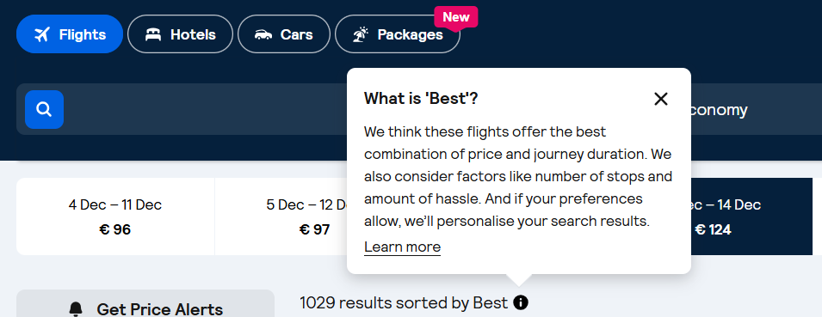

Generally, when the English copy says “best”, it’s safe to translate it the same way. When this is not the case, do not use “best” or other superlatives. Instead, use subjective claims such as “epic prices” or “amazing deals”.

The use of “Discount”

Skyscanner never offer discounts to users. Any discounts come from partners (for example Trip.com), not by Skyscanner.
For this and especially for legal reasons we can therefore never imply that “we offer” or “Skyscanner offers” a discount. This must be translated in a neutral way, i.e. “You are offered a discount”.

Never use the translation or equivalent of “discount” when the English source refers to a “deal” or “price drops” – these are not discounts but results of price fluctuation and it would be legally incorrect to refer to discounts.

Do | Don’t
Drops-ominaisuudella näet lentoja, joiden hinnat ovat laskeneet vähintään 20 %. | Drops-ominaisuudella näet lentoja, jotka ovat vähintään 20 %:n alennuksessa.

Translating sustainability-related content
When localising content about anything related to sustainability for Skyscanner, it’s essential to communicate responsibly and avoid greenwashing. Travel has an undeniable environmental impact, and our language must reflect this honestly and transparently. Use the following principles when translating or adapting sustainability-related content:
- Prefer comparatives over absolutes. Use relative statements such as “X is more sustainable than Y”, rather than implying that any option is fully sustainable.
- Avoid superlatives. Do not use expressions like “the most ecological flight” or “the greenest option”, as they can overstate environmental benefits.
- Use transparent and factual language. Base all claims on clear, measurable data.
- Steer clear of vague or unregulated terms. Avoid words like ‘natural’, ‘green’, ‘non-toxic’, and ‘environmentally friendly’, unless the statement is supported by verifiable, standardised criteria.
- Do not make unsubstantiated claims. Only reference environmental performance when data is available. Never imply that a flight or travel option is “sustainable,” “eco,” “green,” “clean,” “planet-friendly,” or “guilt-free.”
- Avoid reinforcing “green” imagery or symbolism. Be cautious with metaphors and word associations that might imply aviation is environmentally harmless. Overuse of green or nature-themed language can unintentionally suggest a level of sustainability that does not exist in commercial aviation today.
Do | Don’t
Tämä lento aiheuttaa 20 % vähemmän hiilidioksidipäästöjä kuin tyypillinen lento samalla reitillä. | Tämä lento on 20 % ekologisempi/pienipäästöisempi/ympäristöystävällisempi kuin tyypillinen lento tällä reitillä
 | Tämä on ympäristöystävällinen lento
 | Tämä on kaikkein ekologisin lento
 | Tämä on vihreämpi valinta

Accessibility guidelines

See the localised Accessibility guidelines here.

Useful resources and links

Here you can find information on the definition, spelling and inflected forms of words as well as their usage and stylistic variations.
https://www.kielitoimistonsanakirja.fi/
Here you can find information on spelling, punctuation rules, etc.
http://www.kielitoimistonohjepankki.fi/
Here you can find information on punctuation.
http://jkorpela.fi/kielenopas/4.4.html
Here you can find the names of all the countries in seven languages, including Finnish of course.
http://kaino.kotus.fi/maidennimet/index.php?h=fi

